**Chapter 1**

**Introduction**

* 1. **Student Attendance**

Recording student attendance is a crucial administrative task that needs to be done at the beginning of each class. However, it can be time-consuming and challenging to manage, with traditional attendance books being difficult to read and prone to errors in marking attendance.

For educational institutions colleges attendance is one of the most important issues as it plays a role in evaluating a student's final grade. Properly recording attendance is essential for effective planning, management, and functioning of any organization, be it educational or commercial.

Attendance is a measure of the number of students present in college, and it helps in keeping track of their presence and absence. Regular attendance is a significant responsibility for students at all grade levels, as studies have shown that it is correlated with success in college. Attending lectures regularly ensures that the academic learning process is not disrupted, less time is spent on make-up assignments, and students benefit from participating and interacting with others in lectures.

* 1. **Timetable**

A timetable in a system is similar to the schedules students receive in college. Just like a physical timetable, it organizes classes and their timings. However, in the digital world, this module serves a more dynamic purpose, efficiently managing attendance records.

Initially, someone (typically a teacher or an administrator) sets up the timetable for each class within the system. They determine which subjects will be taught on specific days and at what times. This data is then inputted into the system, forming the foundation of the digital timetable.

Students and teachers can easily access this timetable online or through a mobile app. They can view their schedules for the day, week, or even the entire semester. This accessibility ensures that everyone knows where they need to be and when. During class hours, teachers use the system to take attendance. They mark who is present and who is absent, with this information being promptly recorded and stored in the system's database.

Moreover, the system facilitates seamless updates to the timetable. If there are any changes, such as class cancellations or rescheduled sessions, the system can be swiftly updated. This ensures that everyone has access to the most current information, minimizing confusion and disruptions.

* 1. **Submission Report**

Students can use the system to access submission reports, which helps them keep track of their assignments, practical submissions, and term work projects. This feature allows students to see the status of their work, including whether it has been submitted or is still pending. By accessing these reports directly from the system, students can easily monitor their progress and ensure they are meeting deadlines. This feature is especially helpful for students who want to stay organized and stay on top of their academic responsibilities.

**Chapter 2**

**Literature Survey**

**2.1 Study of existing system**

In our college, attendance is marked by calling out each student's roll number and recording their presence in a big table. This process takes a lot of time because it's done manually. Teachers have to go through each roll number, and then mark whether the student is present or absent. It's a slow and tiresome process for both teachers and students. This method isn't very efficient because it can lead to mistakes and takes up valuable class time. Overall, the current system for taking attendance in our college is time-consuming and could be improved.

In our college, making submission reports is a hassle for students. After finishing assignments, they have to gather signatures from faculty for approval. This extra step is tiresome and takes up a lot of time. The process involves lots of paperwork and running around to find the right faculty members. Overall, it's a frustrating task that adds stress to students' already busy schedules. Simplifying this process would make life easier for everyone involved, saving time and reducing the administrative burden on both students and faculty

Overall, the study of the existing system highlights the need for a comprehensive solution that integrates attendance management with submission reporting for term work. By transitioning to a digital platform, educational institutions can streamline administrative tasks, improve accuracy in attendance tracking and term work management, and ultimately enhance the overall educational experience for both faculty and students.

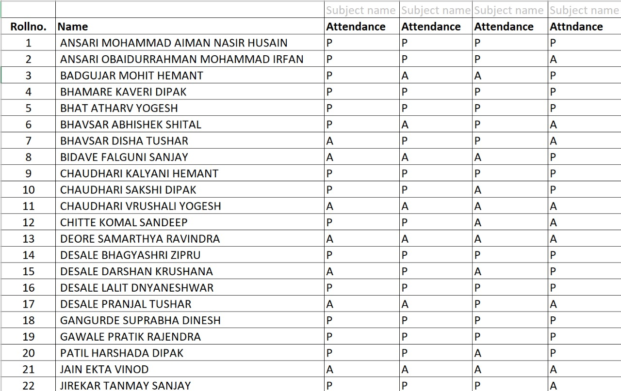

*Fig. 2.1 – Study of existing system*

**2.2 Limitations of existing system**

The existing systems for tracking attendance and managing assignment submissions face several limitations that hinder their effectiveness. One significant challenge is the lack of real-time tracking in attendance systems, which can lead to potential inaccuracies and delays in updating attendance records. This means that attendance information may not be immediately available, making it difficult for educators and administrators to make timely decisions based on accurate data.

Similarly, when it comes to managing assignments and practical submissions, there's a lack of traceability in existing systems. This means that it's often challenging to trace the journey of an assignment from submission to grading, leading to potential errors and inconsistencies along the way. Without a clear and transparent process for tracking assignments, educators may struggle to ensure that all submissions are accounted for and graded accurately.

Overall, the limitations of existing systems boil down to issues of real-time tracking and traceability. Without these features, attendance and assignment management processes are prone to errors, delays, and inaccuracies, ultimately impacting the efficiency and effectiveness of educational institutions.

**2.3 Problem Identification**

1. **Manual Processes:** Many educational institutions still rely on outdated, manual methods for recording and tracking student attendance. These processes are time-consuming, prone to errors, and lack efficiency.
2. **Inaccurate Data:** Manual attendance tracking often leads to inaccuracies in attendance records, including missed entries, duplicate entries, and illegible handwriting. This can result in misleading data and challenges in identifying patterns or trends.

1. **Lack of Real-time Monitoring:** Without real-time monitoring capabilities, educators and administrators struggle to promptly identify and address attendance issues. Delayed detection may lead to missed interventions and decreased student engagement.
2. **Limited Engagement:** Traditional methods of recording attendance may not engage students effectively, leading to a lack of accountability and motivation to attend classes regularly.
3. **Compliance Challenges:** Educational institutions must comply with attendance regulations and reporting requirements. Manual processes make it difficult to maintain compliance and may result in administrative burdens and potential legal issues.

**2.4 Problem Definition**

This system is a web application which will be develop for managing timetable, student attendance (theory and practical) and overall report (no dues).

This web application aims to solve the problem of organizing and tracking various aspects of student life in schools or colleges. It will help manage class schedules, track both theoretical and practical attendance, and generate reports indicating if students have any outstanding dues. By providing a centralized platform for these tasks, it will make it easier for educators and administrators to keep track of student attendance and ensure that all necessary reports are up to date. Ultimately, it aims to streamline administrative processes and improve overall efficiency in educational institutions.

**Chapter 3**

**Scope of the project**

The scope of the project to reduce the time of the teacher as well as student which they wasted by doing traditional attendance and eliminate proxy attendance.

**3.1 User Requirements**

**3.1.1 Admin:**

1. Notice Alert (Holiday notice / Event notice / Important Notice)

**3.1.2 Teacher:**

1. Extra Lecture Notice and Attendance

**3.1.3 Student:**

1. View:

* Attendance (Number of Lectures Attended)
* Submissions (Assignments and Practical)
* Syllabus
* Timetable

1. Submission Report (No dues)
2. Overall Report:

* Total percentage of attendance
* Submissions Report (No dues, Assignment, Practical)

**3.2 System Requirements**

**3.2.1 Software Requirement Platform:**

* Platform: Visual Studio Code
* Programming Language: HTML, CSS, JavaScript, PHP
* Framework: Bootstrap
* Database: MySQL
* Webserver: Apache

**3.2.2 Hardware Requirement:**

* Operating System: Windows OS
* RAM: 2 GB(Min)
* Processor: Intel Core i3

**Chapter 4**

**Proposed Methodology**

**4.1 System Diagram**

Submission report of individual student generated

Database

Student Attendance Management System

Attendance Data

Attendance details of particular lecture/practical

No dues data

Notice uploaded by teachers

Submission report details

Attendance Details

Timetable Details

Students Details

Teacher details

Individual student attendance generated

Student profile

Teacher profile

Student’s list

Timetable of particular Semester and Division

Attendance is updated

Submission report is updated

Notice uploaded

Fig. 4.1 - System Diagram

No dues checked

*Figure 4.1 – System Diagram*

**4.2 Data Flow Diagram**

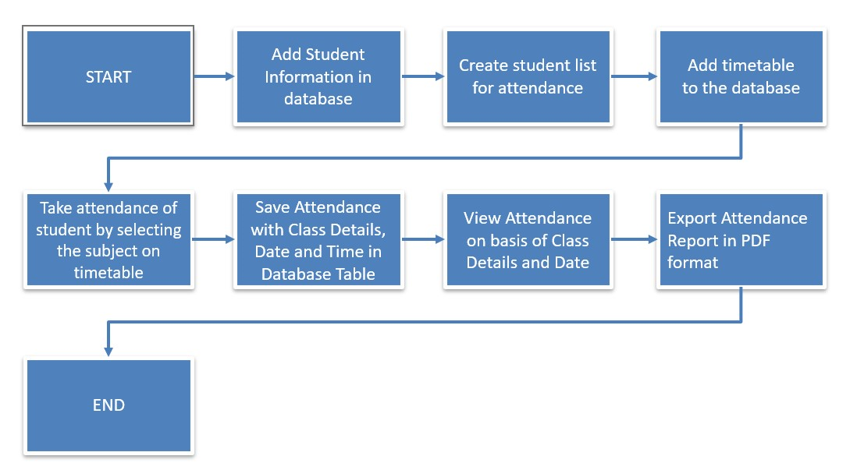

*Fig. 4.2 - Data Flow Diagram*

**4.3 Proposed work**

The proposed work for the student attendance management system involves creating a user-friendly web application that makes it easier for college to keep track of students attending classes. This system will replace old methods with modern technology to make attendance taking faster and more accurate. It will allow teachers to mark attendance with just a few clicks, either on their computers or even on their phones. Students will also benefit because they can check their attendance records online whenever they need to.

Additionally, the system will provide real-time updates on attendance, so teachers can see who's in class right away. This will help them identify students who might need extra support or encouragement to attend regularly. Overall, the goal of this project is to simplify attendance management for colleges and create a more efficient and effective way of keeping track of who's in class.

**4.4. Admin Module**

**4.4.1. Timetable Management:**

Administrators can efficiently manage class schedules and timetables within the system. This feature enables administrators to create, modify, and update class timetables, ensuring accurate scheduling of classes and allocation of resources, with the ability to define class timings.

**4.4.2. Teacher Management:**

Administrators can add, manage teacher’s profiles within the system. They have the authority to assign teaching assignments, adjust workload distributions, and track teaching responsibilities also administrators can manage teacher profiles.

**4.4.3. Student Management:**

Administrators have the ability to oversee student profiles and enrollment details within the system. They can add new students, update existing records, and manage student information such as demographic data, academic progress, and attendance records. Student management features empower administrators to effectively monitor student performance, ensuring accurate tracking of student enrollment and progression.

**4.5 Teacher Module**

**4.5.1. Attendance Management:**

Teachers can easily take attendance for their classes through the system's user-friendly interface, replacing manual methods with digital efficiency. This feature enables quick and accurate recording of student attendance.

**4.5.2. Attendance Viewing:**

Teachers have instant access to view attendance records for their classes, allowing them to monitor student attendance.

**4.5.3. Percentage-wise Attendance:**

Teachers can conveniently view percentage-wise attendance summaries for individual students or entire classes.

**4.5.4. Shadow Timetable:**

The system incorporates a Shadow Timetable feature tailored for teachers, offering visibility into their class schedules and facilitating efficient time management.

**4.5.5. Submission Management:**

Teachers can mark submissions for both micro-projects and term work directly within the system, streamlining the assessment process and ensuring accurate record- keeping. This feature enables teachers to track student progress.

**4.5.6. Attendance Updates:**

Teachers have the ability to update attendance records in real-time, ensuring that data remains accurate and up-to-date. Empowering teachers to maintain comprehensive attendance records throughout the academic term.

**4.6 Student Module**

**4.6.1. View Timetable:**

Students can easily access their personalized timetable within the Student Module. This feature provides students with a comprehensive overview of their class schedules, including course names, instructors, and locations.

**4.6.2. View Attendance:**

The View Attendance feature allows students to track their attendance records in real-time. Students can monitor their attendance status for each class session and view their overall attendance percentage.

**4.6.3. View Submission Report:**

Students can generate submission reports directly from the system. This feature allows them to track the status of their assignments, practical submissions, or term work projects.

**4.6.4. Program Management:**

The system includes a profile management feature where students can view and update their personal information.

**4.6.5. Notice:**

Students can check the notice within the system to stay informed about important announcements, deadlines, or events. This feature allows colleges to communicate important information to students quickly and efficiently.

**Chapter 5**

**Details of designs, working and processes**

**5.1 Modules**

* Admin and Faculty Login – Admin can Login in Admin Dashboard and Faculty can Login in Faculty Dashboard through here using their existing credentials.
* Manage Users – Admin can create account for the Faculty to Login. Admin can remove Faculty account.
* Student Details – Admin can insert data of new student or update the data of the existing student or can delete the record of the existing student.

**5.2.1 Admin Module Design**

The figure 5.2.1 depicts a flowchart outlining a procedural workflow of admin module of student attendance management system Beginning with the "Start" point, the process moves to "Login," where a user attempts to access the system. Subsequently, there's an "Authentication" step to verify the user's identity. Upon successful authentication, the user is directed to the "Admin Home Screen," likely a central interface for administrative tasks. From there, the user can choose to either "Create Timetable" or "Modify Timetables," indicating actions related to managing schedules. Eventually, the user can opt to "Logout" from the system. Throughout the flowchart, decision points in the form of diamond shapes indicate conditional paths based on yes/no responses, possibly related to the success of the login, authentication, and user preferences for further actions or logout. Overall, the flowchart appears to represent a typical user interaction flow in an administrative environment, encompassing login, task execution, and logout functionalities.

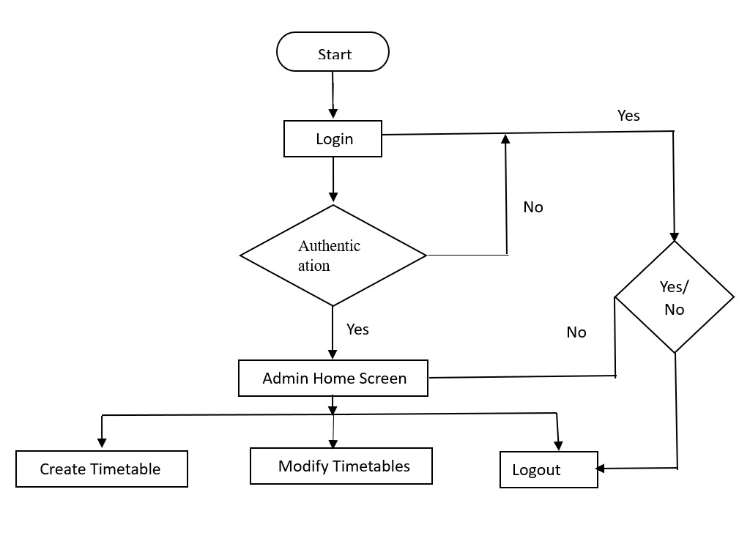

Figure 5.2.1 Admin Module Design

**5.2.2 Faculty Module Design**

The figure 5.2.2 represents a flowchart outlining a procedural workflow, of Teachers model in student attendance management system. Starting with the "Start" point, the process moves to "Login," where a user initiates access to the system. Subsequently, there's an "Authentication" step to verify the user's identity. Upon successful authentication, the user is directed to the "Teacher Home Screen," presumably tailored for teachers' tasks. From there, the user can choose to either "Take Attendance" or "View Timetables," indicating actions related to classroom management and schedule tracking. Eventually, the user can opt to "Logout" from the system. Decision points represented by diamond shapes allow for conditional paths based on yes/no responses, ensuring flexibility within the workflow. In summary, this flowchart illustrates a user interaction flow specifically designed for teachers, encompassing login, task execution, and logout functionalities within an educational or organizational setting.

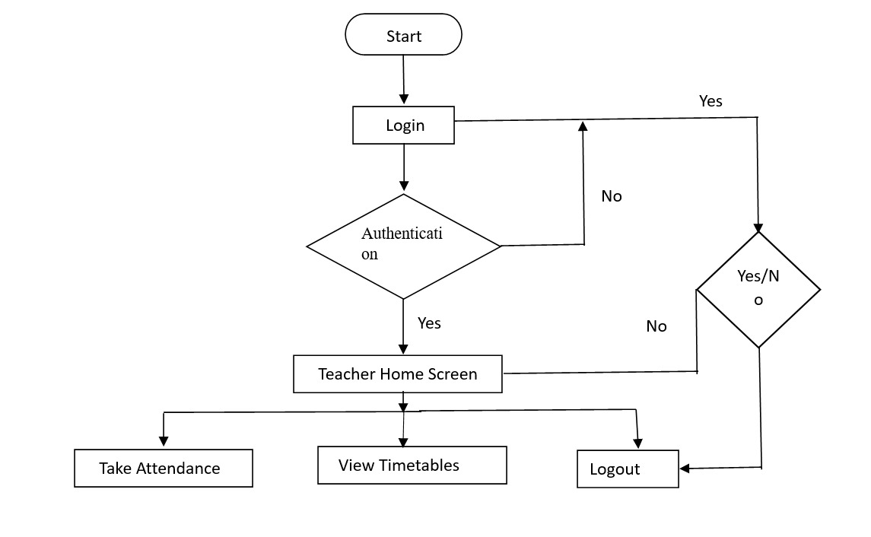

Figure 5.2.2 Faculty Module Design

* + 1. **Student Module Design**

The provided flowchart outlines a user interaction process designed for students within an educational system. Beginning with the "Start" point, the process initiates with a "Login" action, where students attempt to access the system. Following this, an "Authentication" step verifies the student's identity, leading to a decision point determining if the student is valid. Upon validation, students are directed to the "Student Home Screen," offering various options including "View Attendance," "View Timetable," "View Overall Report," and "View Notice." These options enable students to manage their academic information and stay informed about any announcements. The flowchart also includes a "Logout" option for students to exit the system. Decision points throughout the flowchart allow for conditional paths based on yes/no responses, ensuring flexibility in the workflow. Overall, this flowchart illustrates a comprehensive user interaction flow tailored for student users, encompassing login, task execution, and logout functionalities within an educational context.

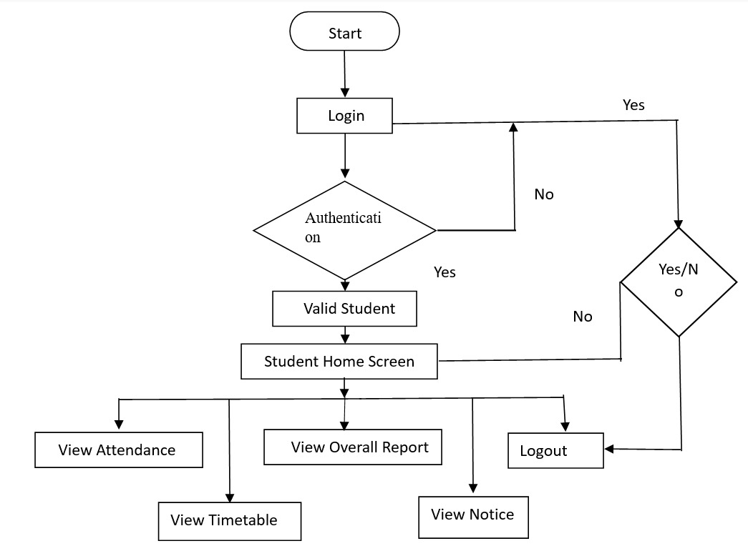

Figure 5.2.3 Student Module Design

**5.3 ER Diagram**



Figure 5.3 ER Diagram

**5.4 Database Structure**

* **Database name: srms**

|  |  |  |  |
| --- | --- | --- | --- |
| **Sr. No** | **Table Name** | **Description** | **Fields of Database** |
| 1 | attendance | This table is used to store the attendance record of student which contains field like id, enrollment_no, subject, attendance_status, date, time, session_type, semester | * id * enrollment_no * subject * attendance_status * date * time * session_type * semester |
| 2 | sr | This table is used to store the submission record of students no dues and PA(TW Submission) of each subject | id  enrollment_no  no_dues, mgt_mp, mgt_tw, pwp_mp, pwp_tw, mad_mp, mad_tw, nis_mp, nis_tw, eti_mp, eti_tw, ede_mp, ede_tw, cpe_tw, cpe_mp, est_mp, est_tw, osy_mp, osy_tw, ajp_mp, ajp_tw, ste_mp, ste_tw, cpp_mp, cpp_tw, acn_mp, acn_tw, jpr_mp, jpr_tw, sen_mp, sen_tw, dcc_mp, dcc_tw, mic_mp, mic_tw, gad_mp, gad_tw, oop_mp, oop_tw, dsa_mp, dsa_tw, cgr_mp, cgr_tw, dbms_mp, dbms_tw, dte_mp, dte_tw |
| 3 | stud_details | This table is used to store the details of students like id, roll number, enrollment number, name, admission year, branch, year, semester, scheme, division, batch | * id * roll_no * enrollment_no * name * admit_year * branch * year * semester * scheme * division * batch |
| 4 | subjects | This table is used to store the details of subjects like course, semester, subject’s complete name, subject’s short forms, teacher, practical, theory | * id * course * semester * sub * short_forms * teacher * practical * theory |
| 5 | teacher_name | This table is used to store the details of teacher like teacher’s short name, complete name, role id, username | * id * short_name * complete_name * role_id * username |
| 6 | timetable | This table is used to store the timetable of class. It stores academic year, with effect from date, scheme, course, semester, division, day, time, subject, theory or practical or tutorial, batch, lab, teacher | * slot * academic_year * witheffectfrom * scheme * course * semester * division * day * time * subject * theory * practical * tutorial * batch * lab * teacher |
| 7 | user | This table is used to store the details of user. It stores username, password, role, role id | * id * username * password * role * role_id |

*Table 5: Database Schema*

**Chapter 6**

**Results and applications**

**6.1 Admin Module**

**6.1.1 Admin: Login**

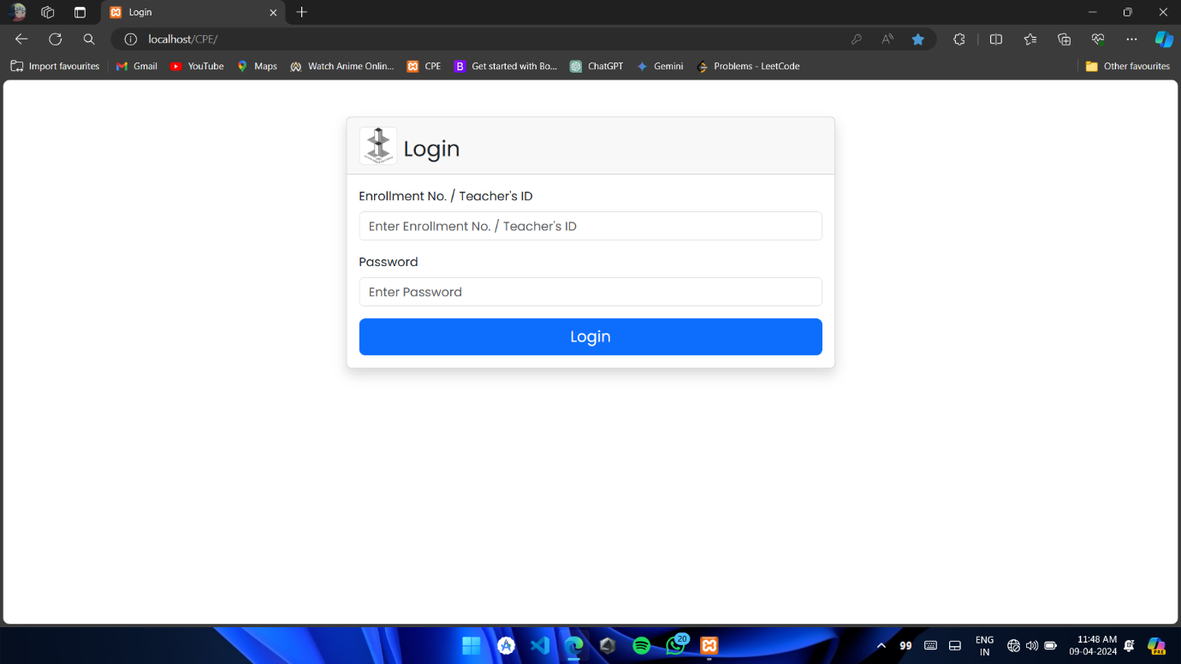

Figure 6.1.1 Admin Login

Figure 6.1.1 shows the login page designed for three different types of users: students, teachers, and administrators. This page is the first thing you see when you want to access the system. Where you need to provide some information to get in.

Administrators, who have special privileges to manage the system, also log in through this page. They use their own credentials to access tools for overseeing the system, such as adding or removing users, adjusting settings, and monitoring overall performance. Teachers also use this page by inputting their specific username and password. Once they're logged in, they can access features customized to their roles. For students, this login page is where they enter their unique username and password to gain access to their accounts.

Each user type has its own designated area in the system, and this login page serves as the gateway for them to enter and start using those areas securely.

**6.1.2 Admin: Dashboard**

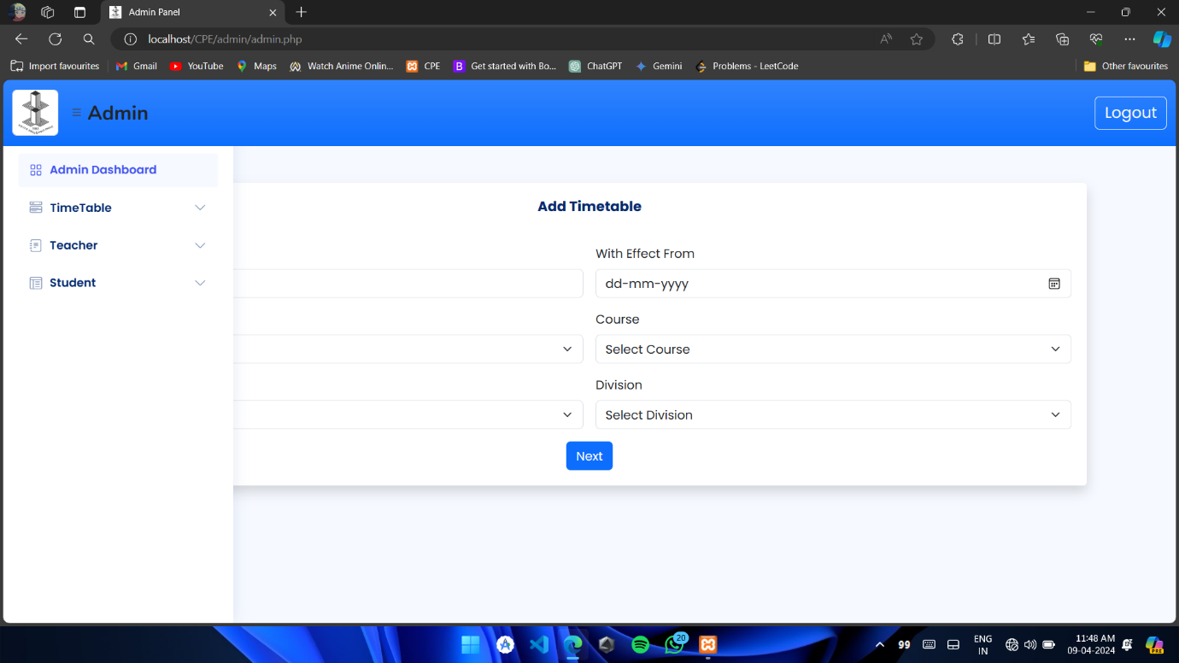

Figure 6.1.2 Admin Dashboard

The "Add Timetable" page is like a digital planner that helps school administrators organize when classes will happen. Imagine it's like a puzzle board where they can place all the pieces (or classes) in the right spots.

Here's how it works: Administrators talk to teachers to find out when they're available to teach their classes. Then, they use this information to fill in the timetable. It's kind of like putting together a schedule for a big event, but instead of people, it's classes that need to be scheduled.

So, on this page, admins can input all the important details like which class is happening when, which teacher is teaching it, and where it will take place. It's a handy tool that helps keep everything organized and running smoothly in the school.

**6.1.3 Admin: Add Timetable**

The "Add Timetable" page, depicted in Figure 6.1.3, offers a structured layout for administrators to meticulously plan class schedules throughout the week. It presents a visual representation of each day, from Monday to the rest of the weekdays, allowing for a systematic organization of classes.

Within this interface, administrators have the flexibility to designate the specific timing for each lecture or class. This entails selecting the start and end times for every session, essentially defining the duration of each educational period.

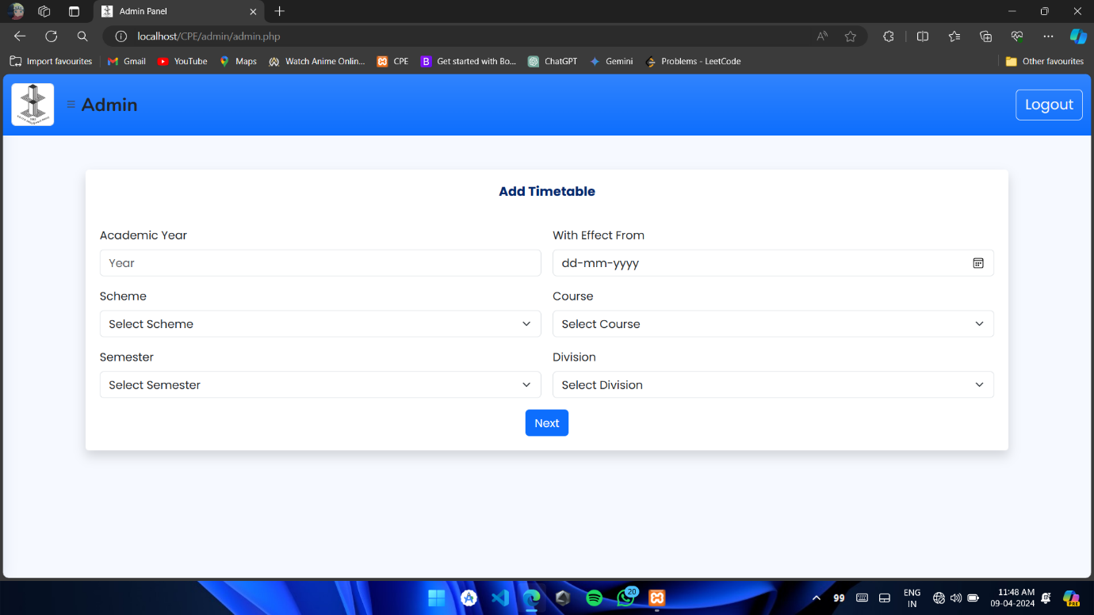

Figure 6.1.3 Admin - Add Timetable (1)

**6.1.4 Admin: Add Timetable**

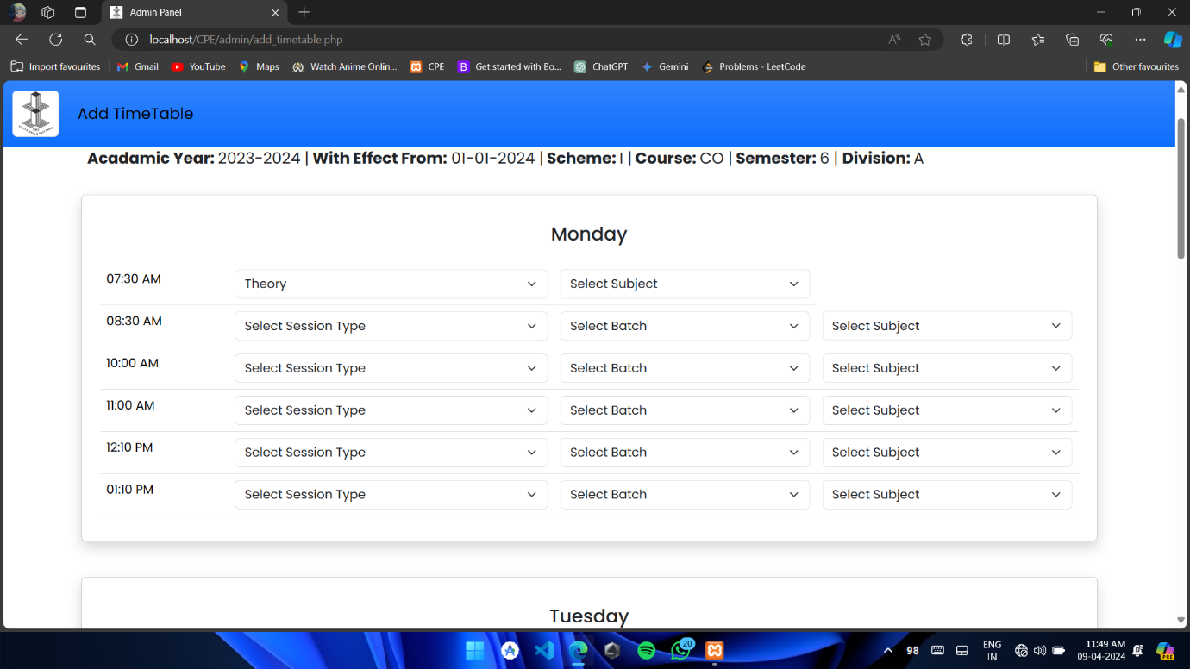

Figure 6.1.4 Admin Add Timetable (2)

In Figure 6.1.4, there's a neat feature called "View Timetable" that lets the admin check out the timetable they just created. Once the admin finishes putting in all the class times and subjects, they just have to click on "View Timetable." This action pulls up the entire timetable on the screen in a clear and organized way. It's kind of like opening a planner to see all your appointments laid out neatly.

This view helps the admin double-check everything they've done. They can make sure all the classes are in the right place and that there are no mistakes. It's like taking a step back to see the whole picture and make sure everything looks good before finalizing it.

**6.1.5 Admin: View Timetable**

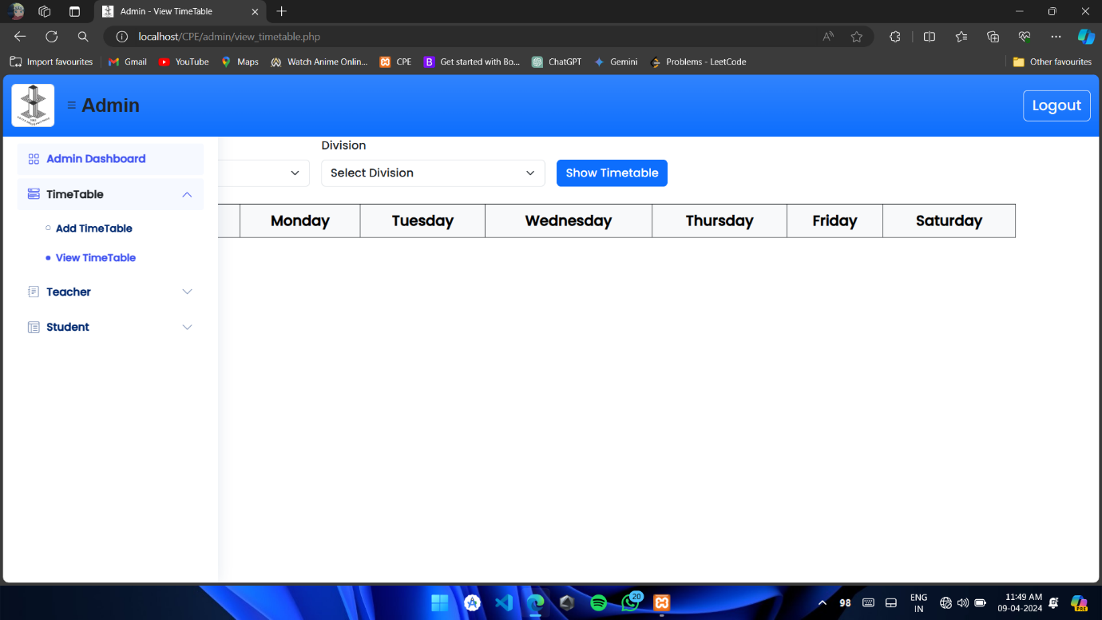

Figure 6.1.5 View Timetable

In Figure 6.1.5, you'll find the "View Timetable" feature, designed to present the timetable to both teachers and students in a user-friendly manner. It's like a window into the schedule, allowing them to easily access the information they need.

To use this feature, all you have to do is select the specific division and semester for which you want to view the timetable. It's as simple as choosing from a dropdown menu or clicking on options provided.

**6.1.6 Admin: Timetable**

In Figure 6.1.6, you'll find the "Display Timetable" feature, which is pretty neat. It shows the timetable for a specific division and semester that the user selects. It's like having a tailor-made schedule just for that particular group of students.

Here's how it works: First, the user picks the division and semester they want to see the timetable for. Think of it as selecting a specific group of students, like the freshmen or the seniors. Once they've made their selection, the timetable for that particular group pops up on the screen.

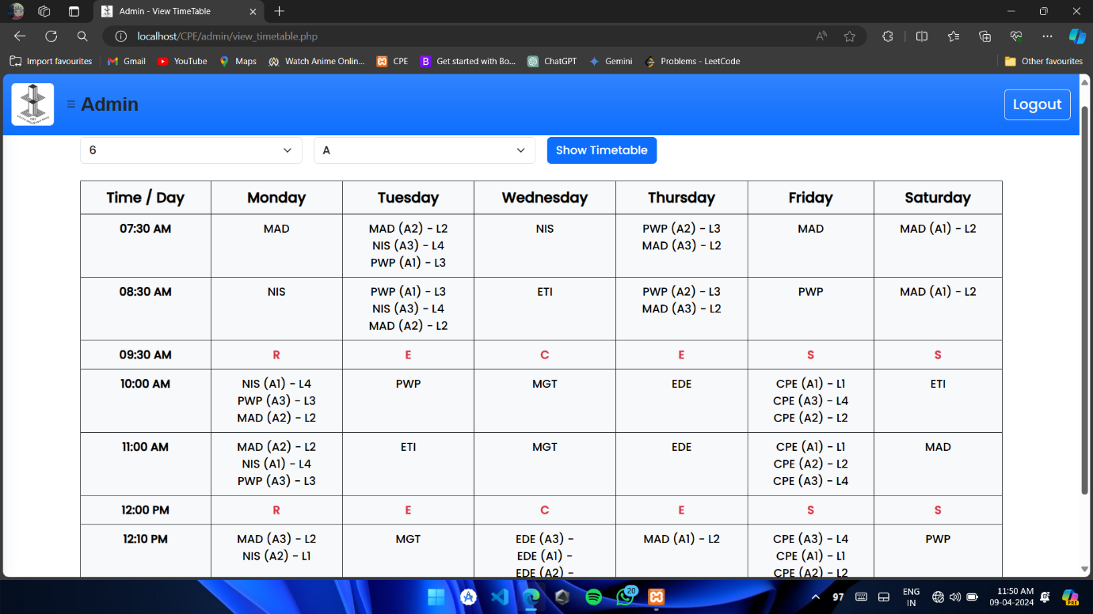

Figure 6.1.6 Timetable

**6.1.7 Admin: Add Teachers**

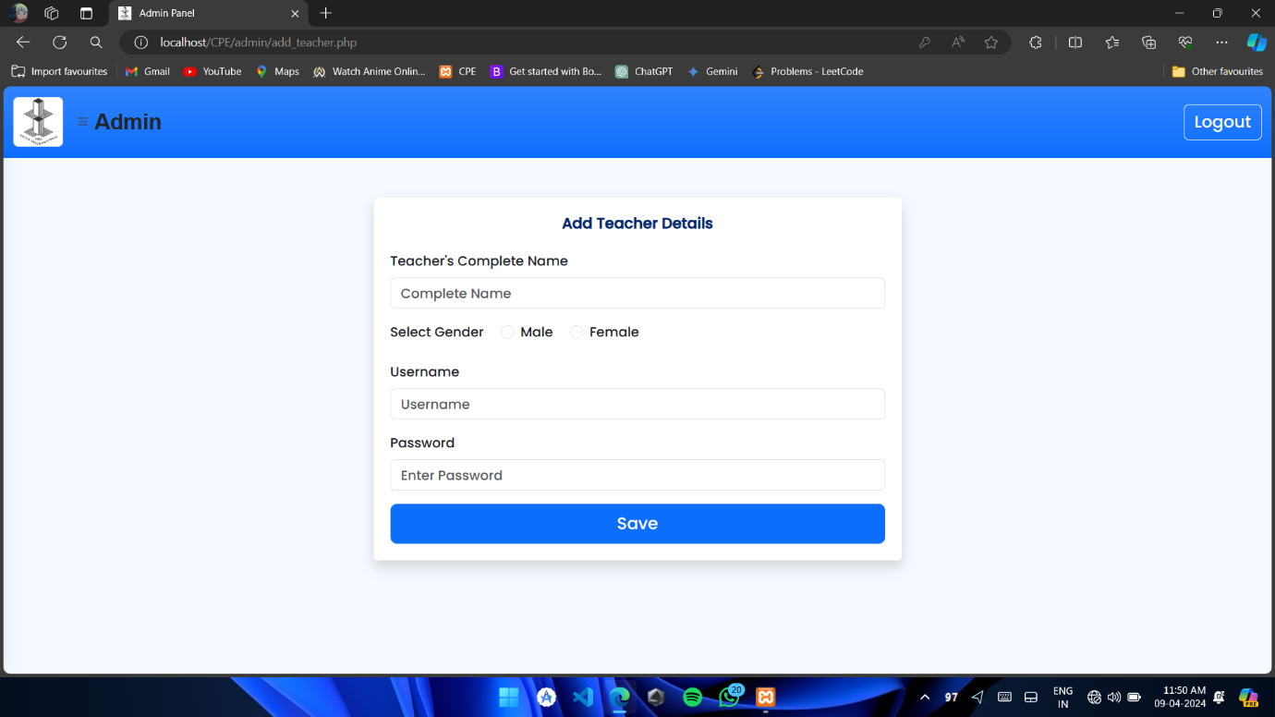

Figure 6.1.7 Add Teachers

In Figure 6.1.7, we see the "Page to Teacher Details," where administrators can input important information about teachers. This includes basic details like the teacher's name and gender, as well as more technical information such as a username and password. These login credentials are crucial because they allow teachers to access the system and manage their tasks.

Administrators fill in the teacher's name, specifying whether they're male or female. Then, they create a unique username and password for each teacher. These credentials serve as keys, granting access to the system. Just like how you use a username and password to log in to your email or social media accounts, teachers use theirs to enter the system and perform their duties.

**6.1.8 Admin: Add No Dues**

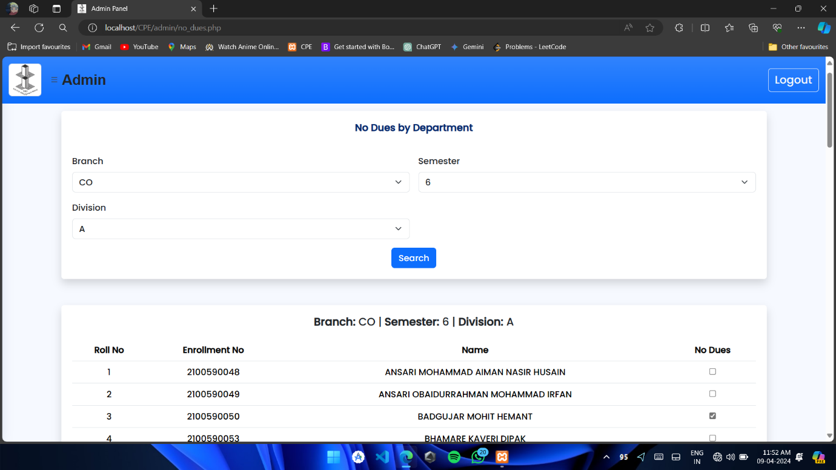

Figure 6.1.8 Add No Dues

In Figure 6.1.8, we have the "No Dues Page," which serves as a record of students categorized by their branch, semester, and division within the college. This page displays a list of students, making it easy for administrators or relevant personnel to track their financial status.

Each student's name is listed alongside a checkbox. If a student has fully paid their college fees, the checkbox next to their name will be marked as checked. However, if they haven't paid their fees in full, the checkbox remains empty.

**6.2 Teacher Module**

**6.2.1 Teacher Welcome Page**

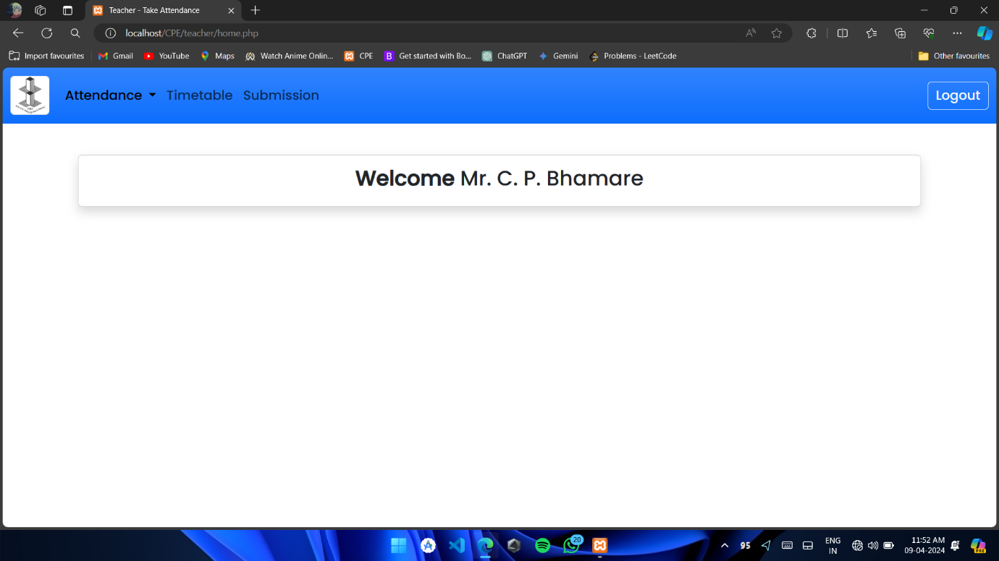

Figure 6.2.1 Teacher Welcome Page

The figure 6.2.1 depicts a welcome page tailored for teachers when they log in to their system. At the forefront, prominently displayed, is the name of the teacher. This name is dynamically fetched and displayed based on the input provided by the teacher during the login process. It serves as a personalized touch, instantly identifying the teacher and creating a sense of familiarity and ownership within the system.

This feature not only enhances user experience but also adds a level of professionalism and personalization to the interface. By displaying the teacher's name upfront, the system acknowledges the individuality of each user, reinforcing their identity within the platform.

Moreover, this personalized welcome page sets a positive tone for the teacher's interaction with the system, making them feel valued and recognized from the moment they log in. It creates a welcoming atmosphere and fosters a stronger connection between the teacher and the platform.

**6.2.2 Teacher: Taking attendance**

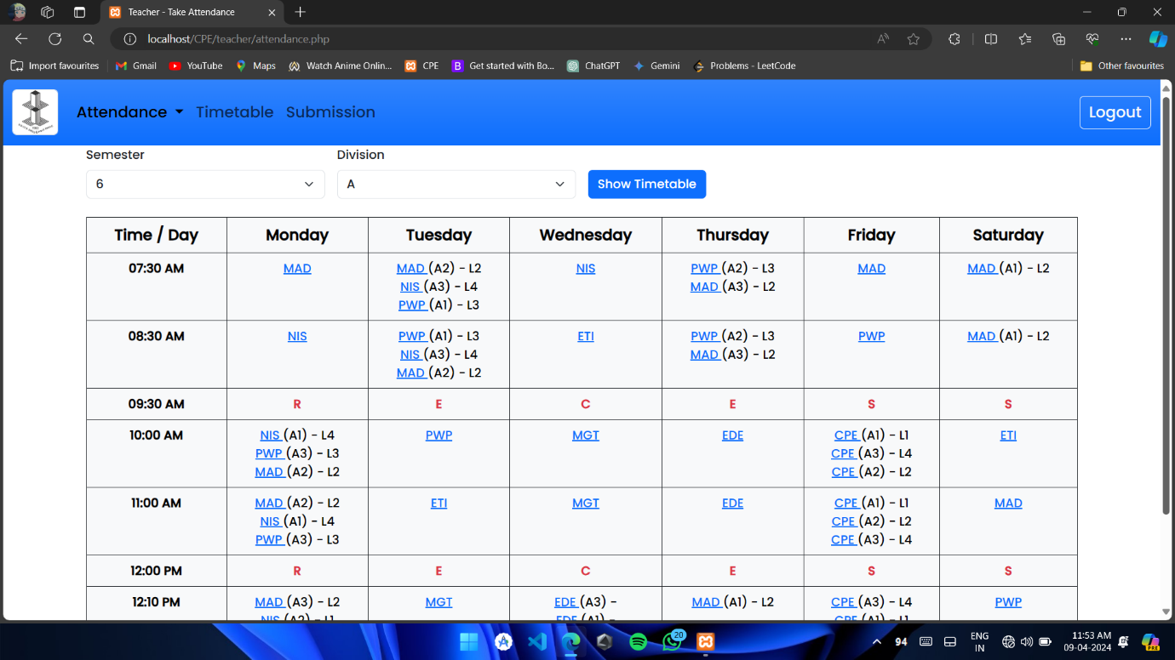

Figure 6.2.2 Taking Attendance

Within the teacher's system, there's a section dedicated to the timetable. Teachers can access this section by navigating through the interface. Once they're there, they have the option to choose the semester and division they want to view. This allows them to focus on the specific schedule they need to see at that moment. After selecting the semester and division, they simply click on the "Show Timetable" button.

Now, when the timetable is displayed, it shows various lectures or subject names that are part of the chosen semester and division. These lectures or subjects aren't just plain text; they are actually hyperlinks. This means they're clickable.

When a teacher clicks on any of these lecture or subject names, something interesting happens. Instead of just displaying information about the lecture, it opens up a list of students enrolled in that particular subject. This feature allows the teacher to quickly access information about the students associated with a specific subject without having to navigate through multiple pages or sections.

**6.2.3 Teacher: Show Students List**

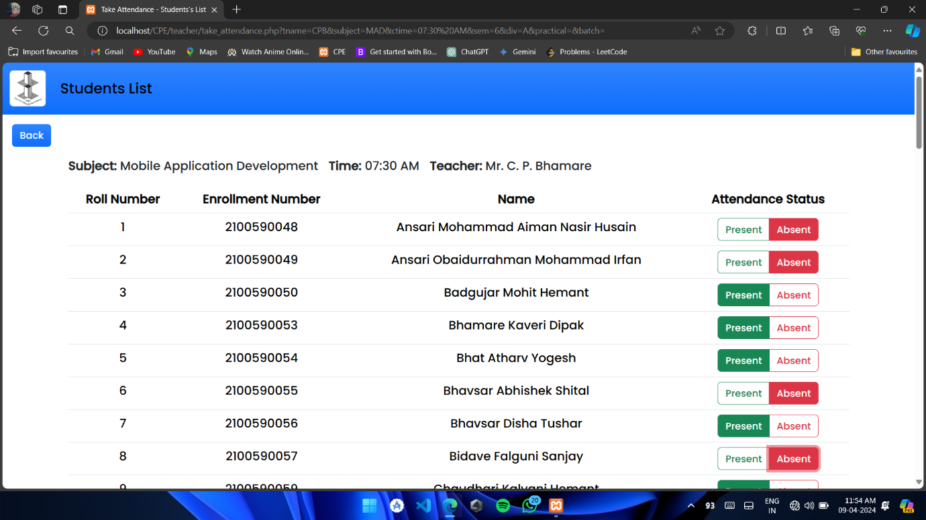

Figure 6.2.3 Show Students List

When a teacher clicks on a hyperlink within the timetable, a new window or section opens up displaying a list of students enrolled in that particular subject. In this list, several pieces of information are presented for each student:

**6.2.4 Teacher: Save Attendance Confirmation**

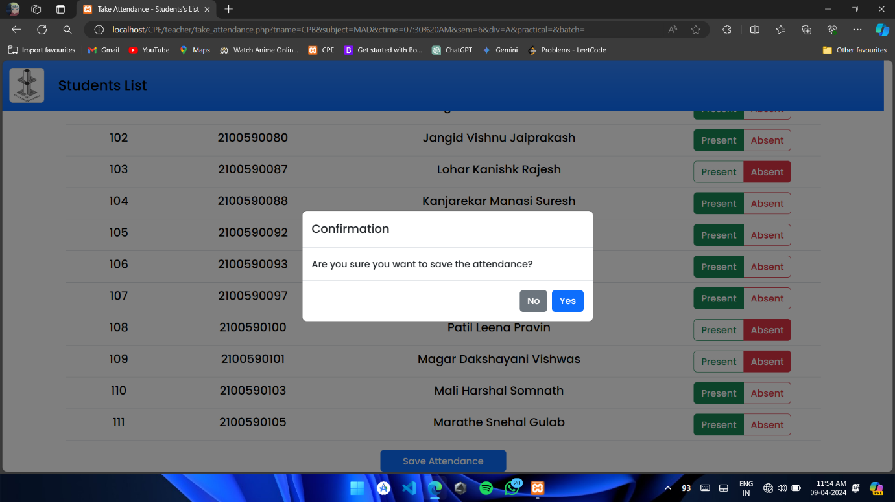

Figure 6.2.4 Save Attendance Confirmation

Once the teacher has marked the attendance for each student listed in the subject's attendance record, they have the option to save this information. Towards the end of the student list, there's typically a button labeled "Save Attendance" or something similar.

When the teacher clicks on this button, it triggers the system to save the attendance record that has been marked. Essentially, it's like confirming and finalizing the changes made to the attendance status of each student.

By clicking "Save Attendance," the system records the attendance data and updates it in the database or storage system. This ensures that the attendance information is securely stored and can be accessed later for reference or reporting purposes.

**6.2.5 Teacher: View Attendance**

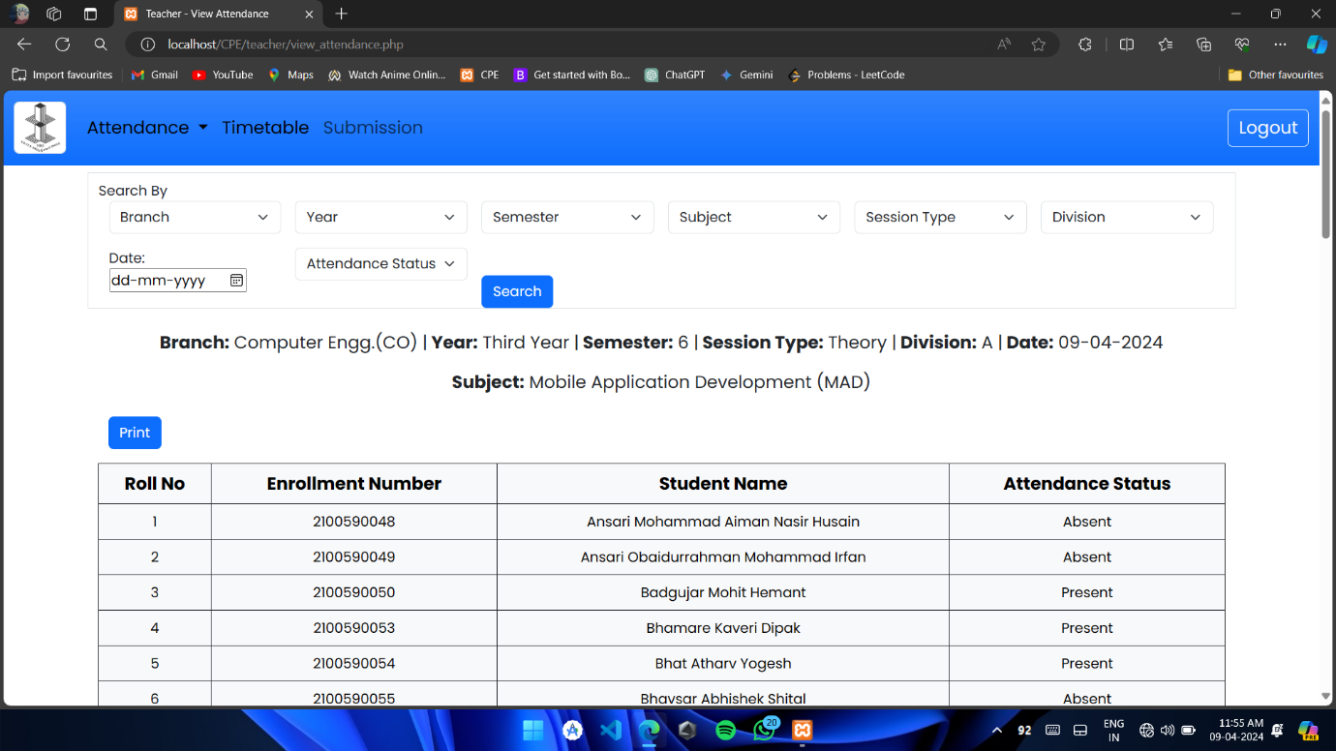

Figure 6.2.5 View Attendance

In this page teacher can view attendance by selecting Branch, Year, Semester, Subject, Session Type, Division, Date and Attendance Status. The Attendance will be then displayed in table format once “Search” button is clicked. If teacher wants he/she can take a print out or save attendance as pdf of specific date.

**6.2.6 Teacher: Attendance Updation**

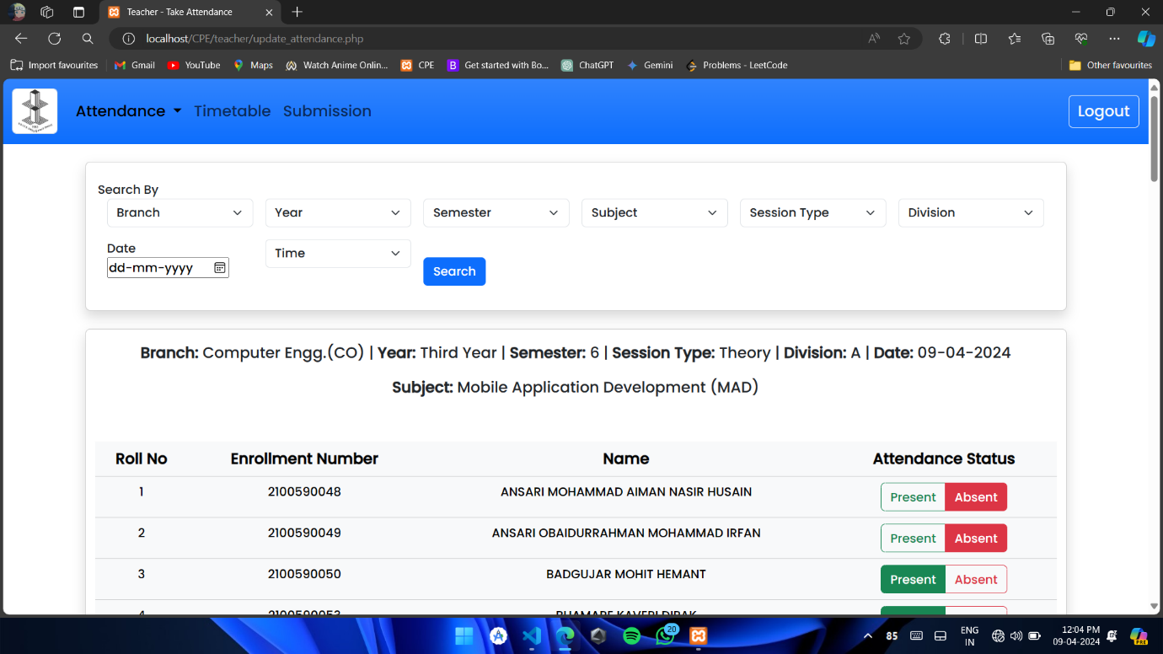

Figure 6.2.6 Attendance Updation

If a teacher makes a mistake while recording attendance, they have the option to update the attendance record within the system. After realizing the error, the teacher can navigate to the attendance section and locate the specific attendance record that needs to be corrected.

Once the attendance record is identified, the teacher can make the necessary changes to correct any mistakes. After the corrections are made, the teacher needs to save the updated attendance information.

Before the updated attendance is officially saved, the system typically provides a confirmation prompt to ensure that the teacher wants to proceed with saving the changes. This prompt asks the teacher if they are sure they want to save the updated attendance record.

**6.2.7 Teacher: Save Attendance Updation**

Once the teacher has marked the attendance for each student listed in the subject's attendance record, they have the option to save this information. Towards the end of the student list, there's typically a button labeled "Save Attendance".

When the teacher clicks on this button, it triggers the system to save the attendance record that has been marked. Essentially, it's like confirming and finalizing the changes made to the attendance status of each student.

By clicking "Save Attendance," the system records the attendance data and updates it in the database or storage system. This ensures that the attendance information is securely stored and can be accessed later for reference or reporting purposes.

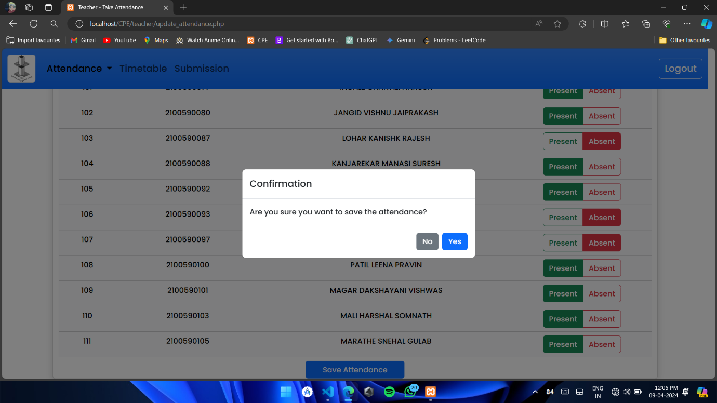

Figure 6.2.7 Save Attendance Updation

**6.2.8 Teacher: Show Attendance Percentage**

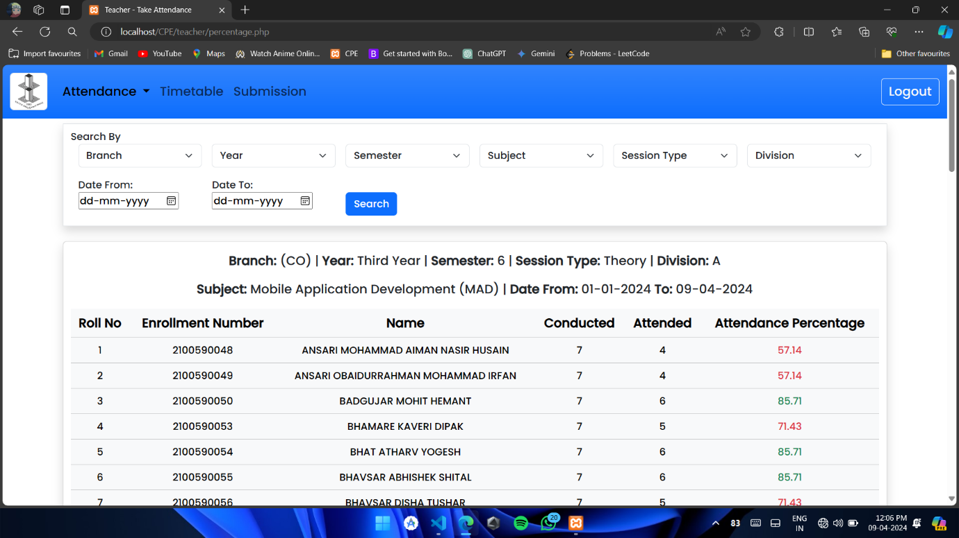

Figure 6.2.8 Show Attendance Percentage

Teachers have access to tools within the attendance management system that allow them to monitor student attendance easily. These tools generate reports or summaries that highlight students with consistently low attendance or a high number of absences.

When teachers review these reports and notice a student with poor attendance, they can take action. This action might involve reaching out to the student to discuss the attendance issues. They can offer support, guidance, and encouragement to help the student improve their attendance.

If necessary, teachers can also involve parents or guardians in the conversation. By working together with parents, they can address any underlying reasons for the student's poor attendance and develop strategies for improvement.

**6.2.9 Teacher: Teacher’s Timetable**

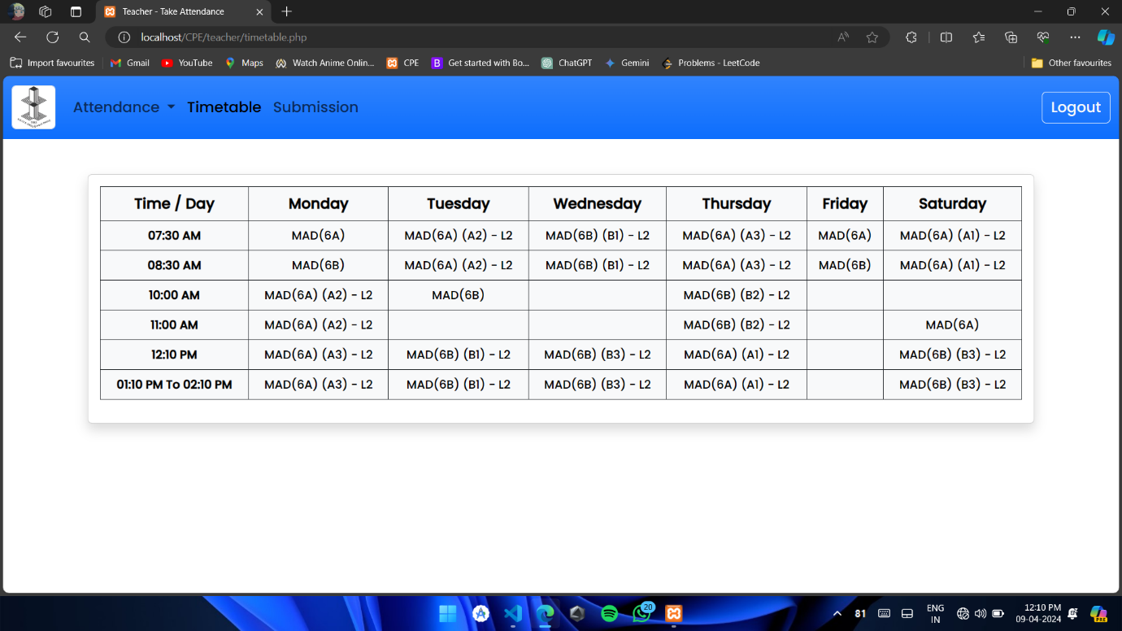

Figure 6.2.9 Teacher's Timetable

In the teacher's system, each teacher has access to their own personalized timetable, often referred to as their "shadow timetable." This timetable shows the teacher's schedule for the day, including details such as the classes they need to teach and any other responsibilities they have.

One useful feature of this shadow timetable is that it also indicates which lab or classroom is available or free to conduct practical sessions. This information is important for teachers, especially those who need to organize and plan laboratory sessions or practical classes for their students.

By consulting their shadow timetable, teachers can quickly identify the time slots when labs are not already booked for other classes or activities. This allows them to schedule their practical sessions efficiently, ensuring that they have access to the necessary facilities without conflicting with other teachers' schedules.

**6.2.10 Teacher: Submission**

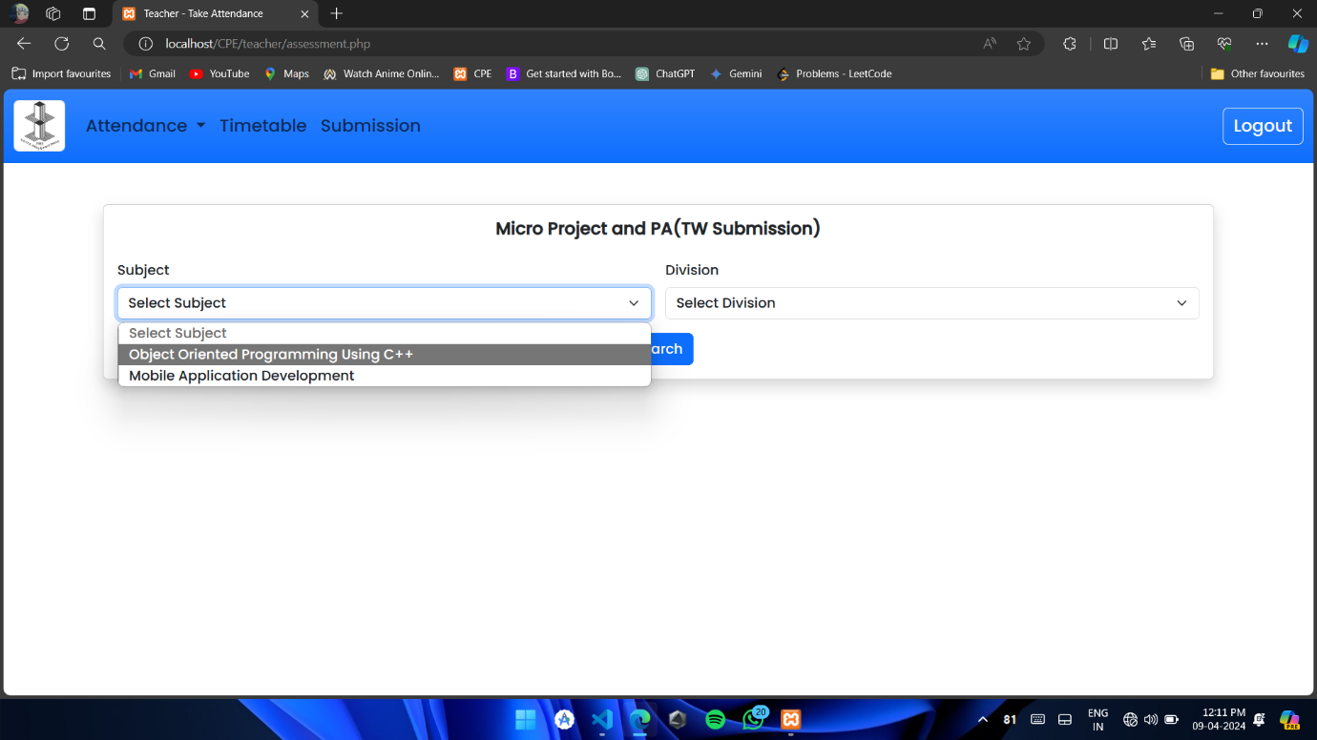

Figure 6.2.10 Submission

Having this visibility into lab availability helps teachers plan their lessons effectively and ensures that students have access to the resources they need for hands-on learning experiences. It streamlines the process of scheduling practical sessions and helps optimize the use of laboratory facilities within the educational institution.

Overall, the shadow timetable provides teachers with a convenient way to manage their schedules and plan their teaching activities, including practical classes, in an organized and efficient manner.

**6.2.11 Teacher: Submission (Term Work)**

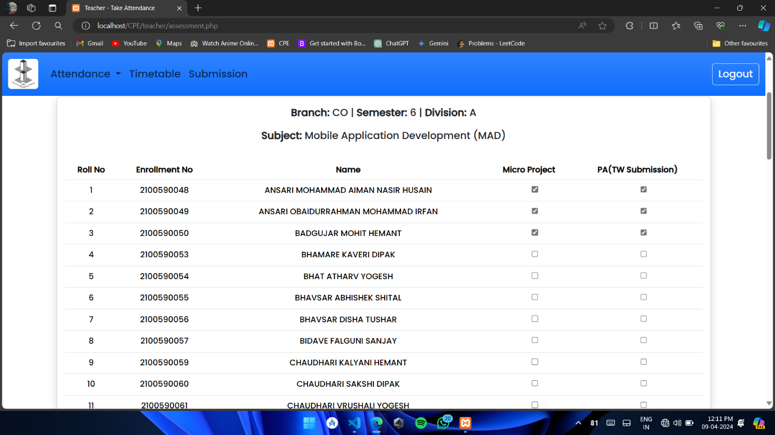

Figure 6.2.11 Submission (Term Work)

When a teacher logs into their account, they are presented with a section that displays the particular subjects they teach. This section is customized to show only the subjects relevant to that specific teacher, making it easier for them to access the information they need.

Within this section, there is an option for the teacher to select the division or class they want to view. This selection allows the teacher to filter the student list based on the chosen division, focusing on the students who are enrolled in that particular class.

**6.2.12 Teacher: Save Submission**

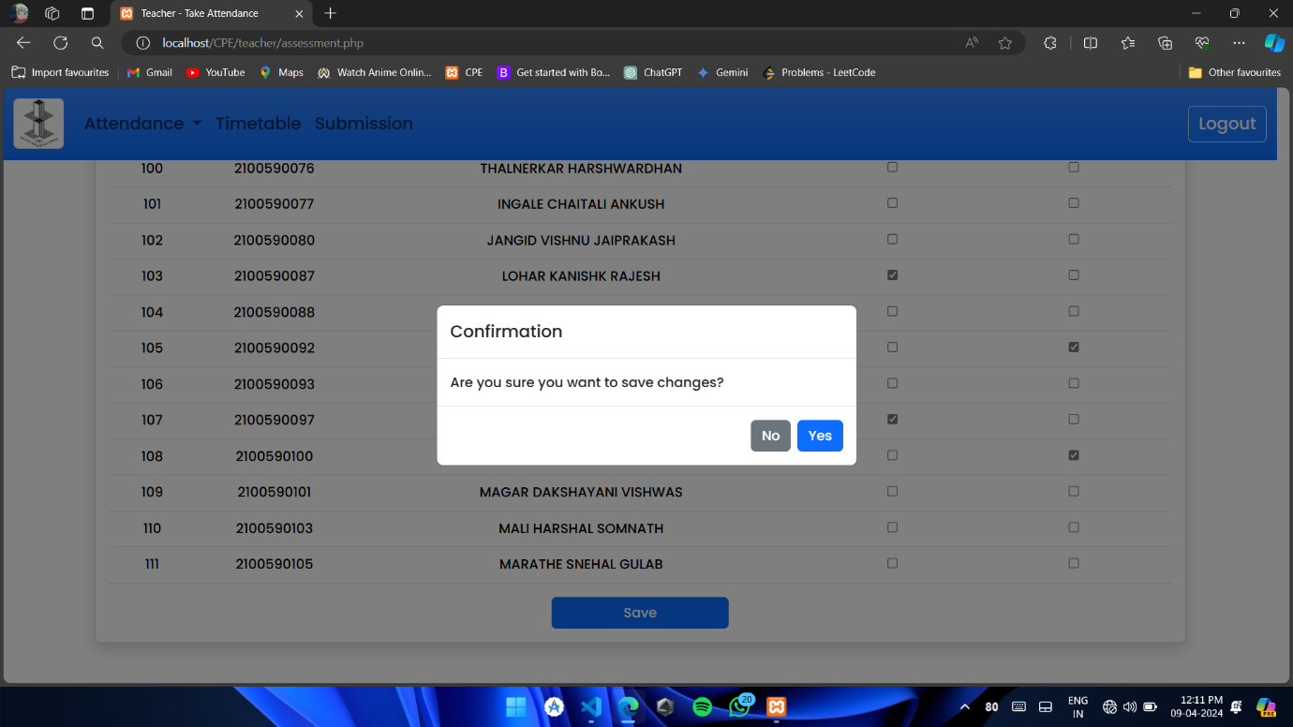

Figure 6.2.12 Save Submission

Within the teacher's system, there's a section where the student list is displayed. This list includes the names of students enrolled in the particular class or division that the teacher has selected. It serves as a convenient way for teachers to keep track of student participation and submissions.

Next to each student's name, there's a checkbox displayed. This checkbox acts as a simple tool for the teacher to mark whether a student has submitted an assignment, project, or any other required task. By clicking on the checkbox next to a student's name, the teacher can indicate that the student has indeed submitted the required work.

The process is straightforward: when a student submits their assignment or completes a task, the teacher can simply locate the student's name on the list and click on the checkbox next to it. This action checks off the box, indicating that the student's submission has been received and acknowledged by the teacher

**6.3 Student Module**

**6.3.1 Student: View Timetable**

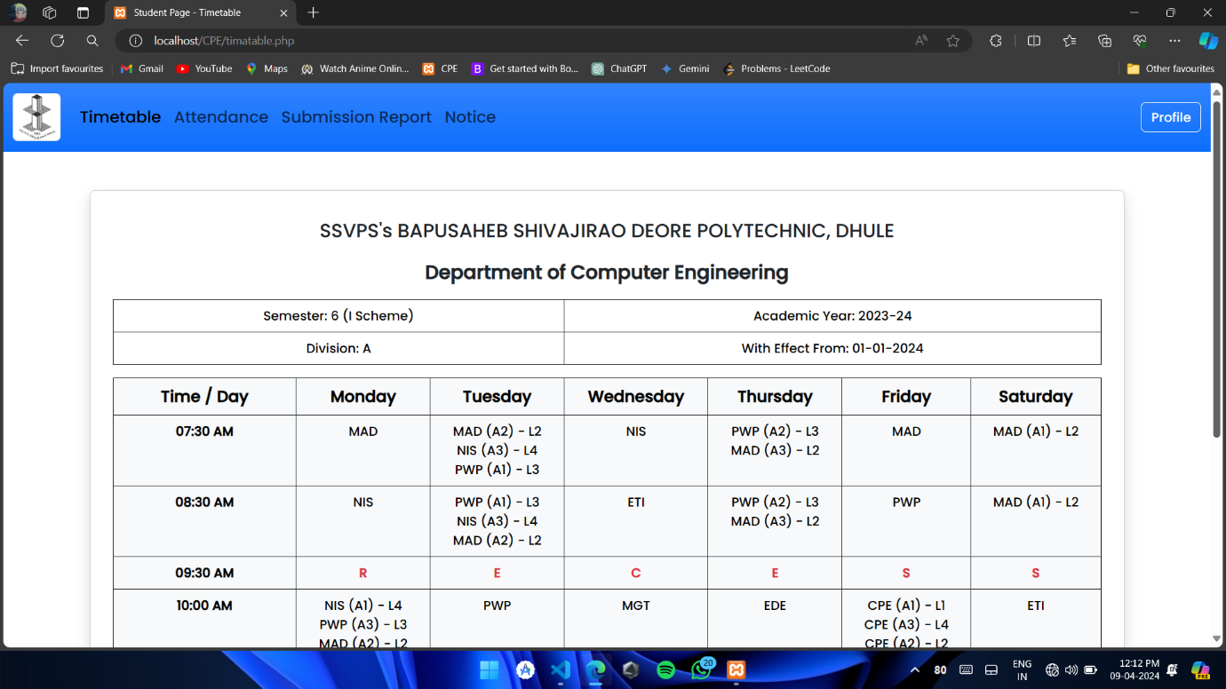

Figure 6.3.1 View Timetable

Figure 6.3.1 displays the Student Home page, which is the first thing students see when they log into the system. It's like the front door to their virtual school world. Once students log in, the system automatically fetches their timetable data and shows it right there on the homepage.

Imagine students opening their digital diary to see what's on their schedule for the day. That's exactly what happens here. They can quickly check when their classes are, what subjects they have, and when they have breaks.

**6.3.2 Student: Attendance Report**

In Figure 6.3.2, we have the "Attendance page," designed to provide students with a comprehensive overview of their attendance records for each subject. It's like a report card specifically for attendance, giving students insight into their class participation.

On this page, students can view their attendance details for every subject they're enrolled in. It shows both the total number of classes conducted and the number of classes they've attended, broken down into lectures, practical and tutorials. Essentially, it's like a tally sheet for tracking their presence in different types of classes.

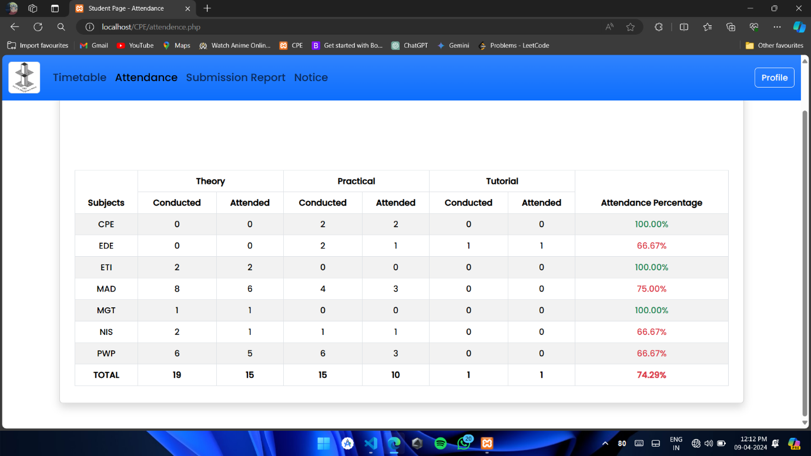

Figure 6.3.2 Attendance Report

**6.3.3 Student: Assessment Status**

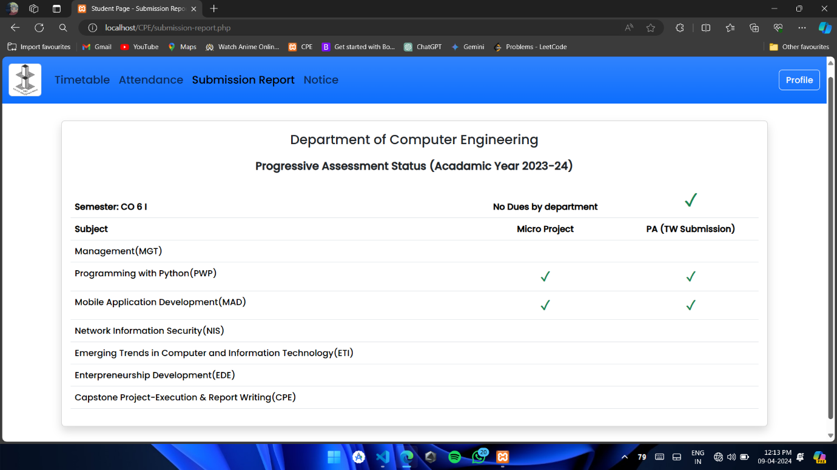

Figure 6.3.3 Submission Report

In Figure 6.3.3, we introduce the "Submission Report" feature, which allows students to review their term work submissions. It's like having a progress report handy, showing how they're doing in each subject.

When a student clicks on "Submission Report" in the Navigation bar, they're taken to a page where they can see feedback on all their submitted work. This feedback comes from their subject teachers and helps them understand their performance and areas for improvement.

**6.3.4 Student: Notice**

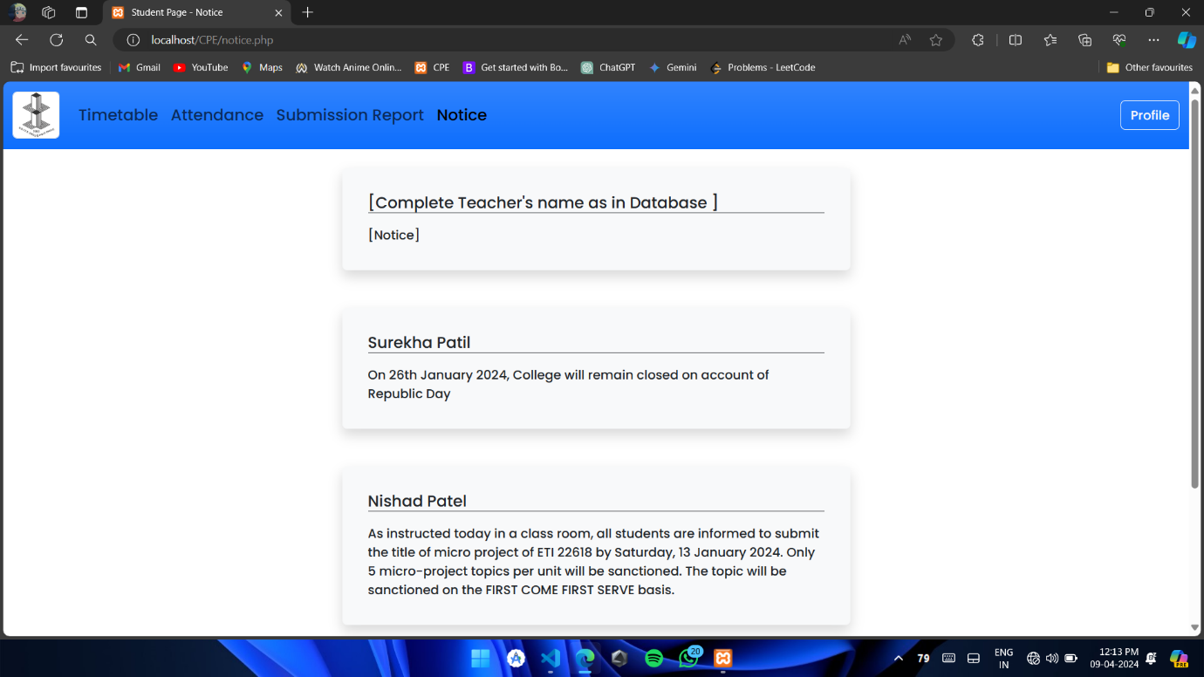

Figure 6.3.4 Notice

In Figure 6.3.4, you'll find the "Notice Section," a place where students can view messages or announcements shared by their teachers. It's like a bulletin board in a school hallway, but digital.

Here's how it works: Teachers can post messages or notices in this section, which are then accessible to all students. These messages could be about upcoming assignments, important reminders, or any other information the teacher wants to communicate to the class.

**6.3.5 Student: View Profile**

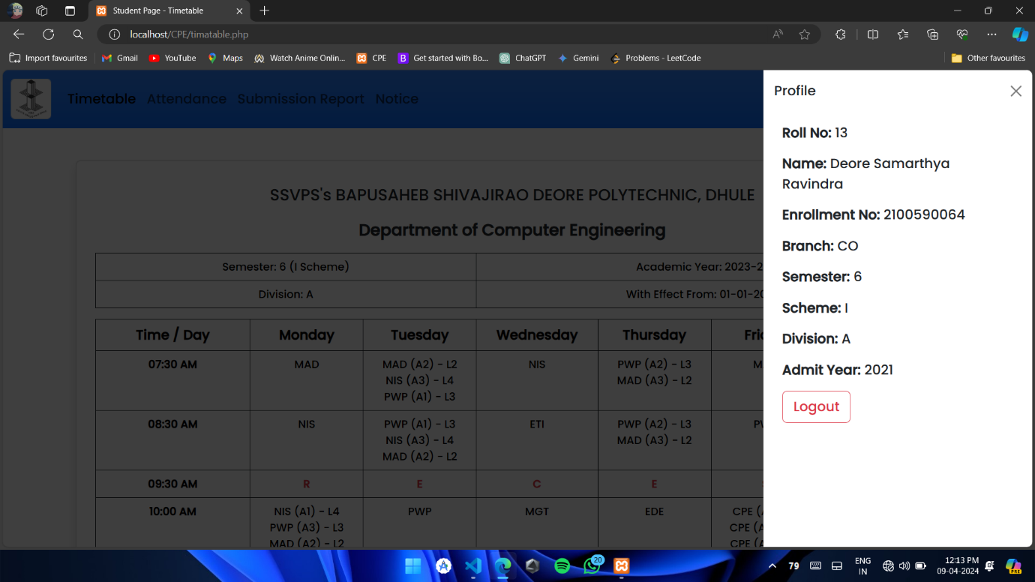

Figure 6.3.5 View Profile

Figure 6.3.5 showcases the "Student Profile" feature, offering students a detailed overview of their personal information, akin to the details present on their student ID card. This profile includes essential details such as the student's roll number, full name, enrollment number, branch of study, current semester, academic scheme, division, and admission year.

Imagine this feature as a digital version of a student's ID card. By accessing their profile, students can easily access and review their pertinent information, much like they would with a physical ID card. This information encompasses key identifiers like their roll number, which serves as a unique identifier within the institution. Additionally, students can view their full name, ensuring accuracy in records and identification purposes.

**6.4 Test cases**

Test case is an object for execution for other modules in the architecture does not represent any interaction by itself. A test case is a set of sequential steps to execute a test operating on a set of predefined inputs to produce certain expected outputs. There are two types of test cases: -manual and automated. A manual test case is executed manually while an automated test case is executed using automation.

In system testing, test data should cover the possible values of each parameter based on the requirements. Since testing every value is impractical, a few values should be chosen from each equivalence class. An equivalence class is a set of values that should all be treated the same.

Ideally, test cases that check error conditions are written separately from the functional test cases and should have steps to verify the error messages and logs.

Realistically, if functional test cases are not yet written, it is ok for testers to check for error conditions when performing normal functional test cases. It should be clear which test data, if any is expected to trigger errors.

**6.4.1 Teacher and admin login form**

|  |  |  |  |  |  |  |  |
| --- | --- | --- | --- | --- | --- | --- | --- |
| **Sr no.** | **Test case id** | **Test case name** | **Test case desc** | **Step** | **Expected**  **result** | **Actual Result** | **Status** |
| 1 | Login admin | Validate login | To verify that login name on login page | Enter the login name and password and click submit button | Login successful or an error message “Invalid login or password”  must be displayed | Login successful | Pass |
| 2 | Login Staff | Validate login | To verify that login name on login page | Enter the login name and password and click submit button | Login successful or an error message “Invalid login or password” must be  displayed | Login successful | Pass |
| 3 | Password | Validate password | To verify that password on login page | Enter password and login name click  submit button | An error message “password invalid” must be displayed | No error message is displayed | Fail |

*Table 1: Teacher and Admin Login Form Test Cases*

**6.4.2 Admin module Test Case:**

|  |  |  |  |  |  |  |  |
| --- | --- | --- | --- | --- | --- | --- | --- |
| **Sr no.** | **Test Case id** | **Test Case name** | **Test Case desc** | **Steps** | **Expected result** | **Actual result** | **Status** |
| 1 | Create student Details | Validate allocation form | To allocate separate roll no for the students | Nothing entered and click submit button | An error message student name not equal to null must be displayed | Inserted successful | PASS |
| 2 | Create Staff details | Validate allocation form | To allocate separate subject username e password d for the staffs | Nothing entered and click submit button | An error message staff details password, username e not equal to null must be displayed | Inserted successful | PASS |
| 3 | Create time table | Validate allocate period form | To verify that data stored on database | Nothing entered and click submit button | An error message not click not allocation subject table not equal to null must be displayed | Inserted successful | PASS |
| 4 | view | Check details of all data | To verify that data stored on database | generate | An error message return null will be displayed | An error message return null will be displayed | PASS |

*Table 2: Admin Module Test Case*

**6.4.3 Teacher Module take attendance and view timetable:**

|  |  |  |  |  |  |  |  |
| --- | --- | --- | --- | --- | --- | --- | --- |
| **Sr no.** | **Test Case**  **id** | **Test Case name** | **Test Case**  **desc** | **Steps** | **Expected result** | **Actual result** | **Status** |
| 1 | Take student Attendance | open attendance time table | select fields for opening time table of particular division | enter correct Semester and Division in the fields | timetable of particular semester and division should be displayed | time table is displayed of submitted data | PASS |
| 2 | Take student Attendance | check student attendance list | select subject from timetable and mark student present | click on particular subject, mark student present or absent | Student list of particular semester and division should be displayed | student list is displayed | PASS |
| 3 | Take student Attendance | check student attendance is submitted or not | select present students and submit the attendance of students | mark students present and then submit the attendance | attendance should be submitted | attendance is submitted | PASS |
| 4 | View student Attendance | view the attendance of students | select lecture fields to check the attendance of particular lecture/practical | fill the fields correctly and click search | Attendance of particular lecture/practical is displayed | attendance is displayed | PASS |
| 5 | View student Attendance | View students’ attendance of particular | select the subject, semester, course, session type for viewing | select the subject, semester, course, session type and click search | Attendance of all students for particular subject | Attendance of all students for particular subject is displayed | PASS |
|  |  | subject teacher | attendance |  | should be displayed |  |  |
| 6 | view timetable of particular teacher | view timetable of particular teacher | view timetable of particular teacher to know their lecture/practical schedule | click on timetable | timetable should be displayed | timetable is displayed | PASS |
| 7 | micro project and practical submission | micro project and practical submission | mark submission of practical and microproject | click on submission and then select subject and division | students list of particular division with check box should be displayed | students list of particular division with check box is displayed | PASS |
| 8 | micro project and practical submission | micro project and practical submission upload | submit the marked submission of practical and microproject | click the check box and submit the response | response should be submitted | response is submitted | PASS |

*Table 3: Teacher Modules Take Attendance and View Attendance Test Cases*

**6.4.4 Student module Test Case:**

|  |  |  |  |  |  |  |  |
| --- | --- | --- | --- | --- | --- | --- | --- |
| **Sr no.** | **Test Case id** | **Test Case name** | **Test Case desc** | **Steps** | **Expected result** | **Actual result** | **Status** |
| 1 | View profile | view profile info | select the profile and check the details of student | click the profile icon | student details should be displayed | student details are displayed | PASS |
| 2 | view timetable | view class timetable | check the timetable of | Click on timetable and view it | timetable of particular division | timetable of particular | PASS |
|  |  |  | particular student | should be displayed |  | division is displayed |  |
| 3 | View attendance | view attendance of current semester | view attendance of all subjects and attendance percentages | click on attendance and check attendance percentage | correct attendance of student should be displayed | correct attendance of student is displayed | PASS |
| 4 | View Submission report | view submission report | view the submission of all practical’s and microproject | click on submission report and check the completed submissions | submission report of student should be displayed | submission report of student is displayed | PASS |
| 5 | View Notice | view teacher notices | view teacher’s notice | click on notice and view it | latest notice added by teacher should be displayed | latest notice added by teacher is displayed | PASS |

*Table 4: Student Module Test Cases*

**6.4.5 Defect Report**

After uncovering a defect (bug), testers generate a formal defect report. The purpose of a defect report is to state the problem as clearly as possible so that developers can replicate the defect and fix it.

|  |  |
| --- | --- |
| **ID** | 1 |
| **Project** | Student Attendance Management System |
| **Product** | Login Module |
| **Release Version** | 1 |
| **Module** | Login |
| **Detected Build Version** | 1 |
| **Summary** | Login fails to display an error message for an invalid password |
| **Description** | The login functionality fails to display an error message “password invalid” when an invalid password is entered and the submit button is clicked |
| **Steps to Replicate** | 1. Navigate to the login page 2. Enter an invalid password in the password field 3. Enter a username in the username field 4. Click the submit button |
| **Actual Result** | No error message is displayed |
| **Expected Result** | An error message “Invalid Password” should be displayed |
| **Attachments** | _ |
| **Remarks** | This defect prevents users from being informed that their password is invalid |
| **Defect Severity** | Medium |
| **Defect Priority** | High |
| **Reported By** | Deore Samarthya Ravindra |
| **Assigned To** | Makhija Dhruv Harish |
| **Status** | Open |
| **Fixed Build Version** | This is the first version that is released |

*Table 5: Defect Report*

**Chapter 7**

**Conclusions And Future Scope**

**7.1 Conclusion**

The System has been a big help in making sure students show up to class on time. It's made things easier for teachers and school staff by keeping track of who's present and who's not. By using technology to do this, it's reduced mistakes and made things run smoother.

**7.2 Future Scope**

* **Dynamic Class Scheduling:**

Implementing dynamic class scheduling that adjusts based on real-time attendance data, optimizing the use of resources and facilitating better student engagement.

* **Personalized Attendance Alerts:**

Providing personalized attendance alerts to students and parents through various communication channels, such as emails, SMS, or app notifications.

* **Mobile Application Enhancements:**

Developing mobile applications for easy accessibility and real-time updates for both students and faculty. Introducing features such as push notifications, class schedule reminders, and in-app communication.

**References**

* Student record management system: <https://www.iitms.co.in/blog/studentrecordmanagementsystem.html>
* The Use of existing systems Student record management:

<https://www.google.com/amp/s/www.softwaresuggest.com/blog/studentrecordmanagementsystem/amp/>

* GitHub Repository:

<https://github.com/kishanrajput23/StudentInformationSystem>

* PHP Tutorial:

https://www.w3schools.com/php/default.asp

https://www.geeksforgeeks.org/php-tutorial/?ref=shm